Step 6: Build a dashboard to show your insights

You’ve created four worksheets, and they're communicating important information that your boss needs to know. Now you need a way to show the negative profits in Tennessee, North Carolina, and Florida and explain some of the reasons why profits are low.

To do this, you can use dashboards to display multiple worksheets at once, and—if you want—make them interact with one another.

Set up your dashboard

You want to emphasize that certain items sold in certain places are doing poorly. Your bar graph view of profit and your map view demonstrate this point nicely.

1. Click the **New dashboard** button.



1. In the **Dashboard** pane on the left, you'll see the sheets that you created. Drag **Sales in the South** to your empty dashboard.
2. Drag **Profit Map** to your dashboard, and drop it on top of the Sales in the South view.

Your view will update to look like this:

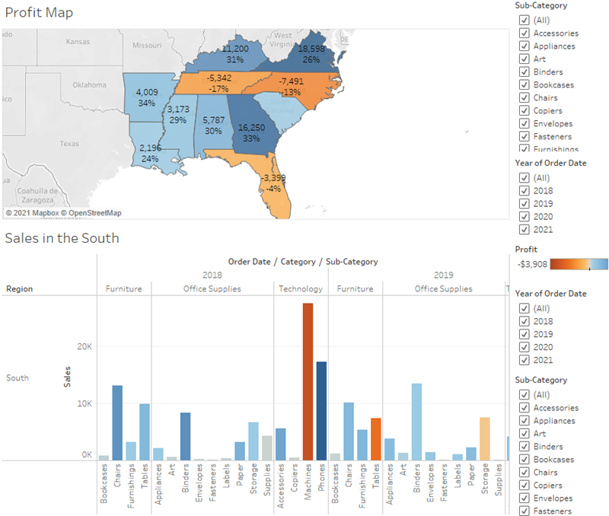

Now you can see both views at once!

But sadly, the bar chart is a bit squished, which isn’t helping your boss understand your data.

Arrange your dashboard

It's not easy to see details for each item under **Sub-Category** from your Sales in the South bar chart. Also, because we have the map in view, we probably don't need the **South region** column in Sales in the South, either.

Resolving these issues will give you more room to communicate the information you need.

1. On Sales in the South, right-click in the column area under the **Region** column header, and clear **Show header**.

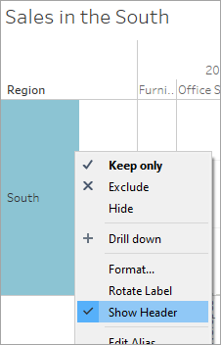

1. Repeat this process for the **Category** row header.

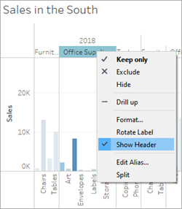

You've now hidden unnecessary columns and rows from your dashboard while preserving the breakdown of your data. The extra space makes it easier to see data on your dashboard, but let's freshen things up even more.

1. Right-click the **Profit Map** title and select **Hide Title**.

The title Profit Map is hidden from the dashboard and even more space is created.

1. Repeat this step for the **Sales in the South** view title.
2. Select the first **Sub-Category** filter card on the right side of your view, and at the top of the card, click the **Remove** icon .
3. Repeat this step for the second **Sub-Category** filter card and one of the **Year of Order Date** filter cards.
4. Click on the **Profit color legend** and drag it from the right to below Sales in the South.
5. Finally, select the remaining **Year of Order Date** filter, click its drop-down arrow, and then select **Floating**. Move it to the white space in the map view. In this example, it is placed just off the East Coast, in the Atlantic Ocean.

Try selecting different years on the Year of Order Date filter. Your data is quickly filtered to show that state performance varies year by year. That's nice, but it could be made even easier to compare.

1. Click the drop-down arrow at the top of the **Year of Order Date** filter, and select **Single Value (Slider)**.

Your view updates to look like this:

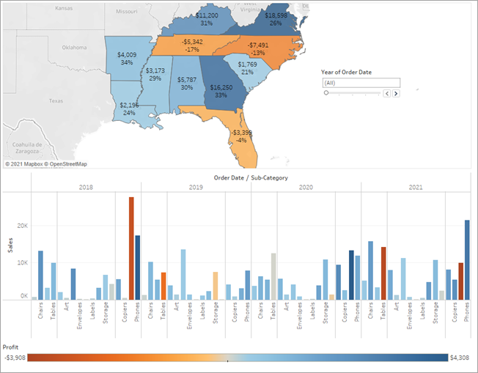

Learn more: Differentiate Floating vs. Tiled objects on a dashboard

Now your dashboard is looking really good! Now, you can easily compare profit and sales by year. But that’s not so different from a couple pictures in a presentation—and you're using Tableau! Let's make your dashboard more engaging.

Check your work! Watch "Arrange your dashboard" in action

*Click the image to replay it*



Add interactivity

Wouldn't it be great if you could view which sub-categories are profitable in specific states?

1. Select **Profit Map** in the dashboard, and click the **Use as filter** icon  in the upper right corner.
2. Select a state within the Southern region of the map.

The Sales in the South bar chart automatically updates to show just the sub-category sales in the selected state. You can quickly see which sub-categories are profitable.

1. Click an area of the map other than the colored Southern states to clear your selection.

You also want viewers to be able to see the change in profits based on the order date.

1. Select the **Year of Order Date** filter, click its drop-down arrow, and select **Apply to Worksheets** > **Selected Worksheets**.
2. In the Apply Filter to Worksheets dialog box, select **All in dashboard**, and then click **OK**.

This option tells Tableau to apply the filter to all worksheets in the dashboard that use this same data source.

Explore state performance by year with your new, interactive dashboard!

Check your work! Watch "Add interactivity" in action

Here, we filter Sales in the South to only items sold in North Carolina, and then explore year by year profit.

*Click the image to replay it*



Rename and go

You show your boss your dashboard, and she loves it. She's named it "Regional Sales and Profit," and you do the same by double-clicking the **Dashboard 1** tab and typing **Regional Sales and Profit**.

In her investigations, your boss also finds that the decision to introduce machines in the North Carolina market in 2021 was a *bad idea*.

Your boss is glad she has this dashboard to explore, but she also wants you to present a clear action plan to the larger team. She asks you to create a presentation with your findings.

Good thing you know about stories in Tableau.

Step 7: Build a story to present

You want to share your findings with the larger team. Together, your team might reevaluate selling machines in North Carolina.

Instead of having to guess which key insights your team is interested in and including them in a presentation, you decide to create a story in Tableau. This way, you can walk viewers through your data discovery process, and you have the option to interactively explore your data to answer any questions that come up during your presentation.

Create your first story point

For the presentation, you'll start with an overview.

1. Click the **New story** button.

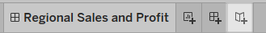

You're presented with a blank workspace that reads, "Drag a sheet here." This is where you'll create your first story point.

Blank stories look a lot like blank dashboards. And like a dashboard, you can drag worksheets over to present them. You can also drag dashboards over to present them in your story.

1. From the **Story** pane on the left, drag the **Sales in the South** worksheet onto your view.
2. Add a caption—maybe "Sales and profit by year"—by editing the text in the gray box above the worksheet.

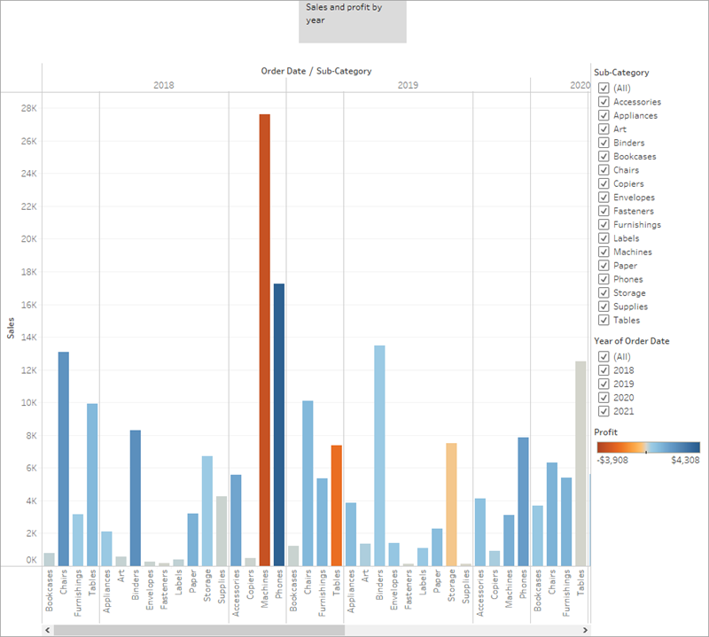

This story point is a useful way to acquaint viewers with your data.

But you want to tell a story about selling machines in North Carolina, so let's focus on that data.

Highlight machine sales

To bring machines into the picture, you can leverage the Sub-Category filter included in your Sales in the South bar chart.

1. In the **Story** pane, click **Duplicate** to duplicate the first caption.

Continue working where you left off, but know that your first story point will be exactly as you left it.

1. Since you know you’re telling a story about machines, on the Sub-Category filter, clear the selection for **(All)**, then select **Machines**.

Now your viewers can quickly identify the sales and profit of machines by year.

1. Add a caption to underscore what your viewers see, for example, "Machine sales and profit by year."

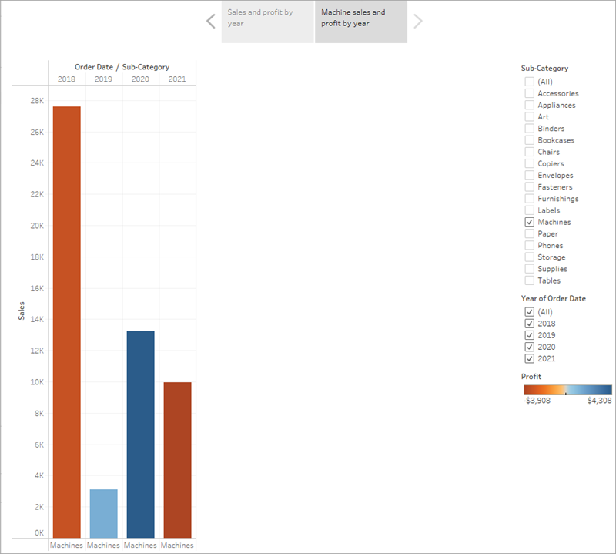

You've successfully shifted the focus to machines, but you realize that something seems odd: in this view, you can't single out which state is contributing to the loss.

You'll address this in your next story point by introducing your map.

Learn more: What's this mini toolbar under your story point caption?

Check your work! Watch "Create your first story point" and "Highlight machine sales" in action.

*Click the image to replay it*



Make your point

The bottom line is that machines in North Carolina lose money for your company. You discovered that in the dashboard you created. Looking at overall sales and profit by year doesn't demonstrate this point alone, but regional profit can.

1. In the **Story** pane, select **Blank**. Then, drag your dashboard **Regional Sales and Profit** onto the canvas.

This gives viewers a new perspective on your data: Negative profit catches the eye.

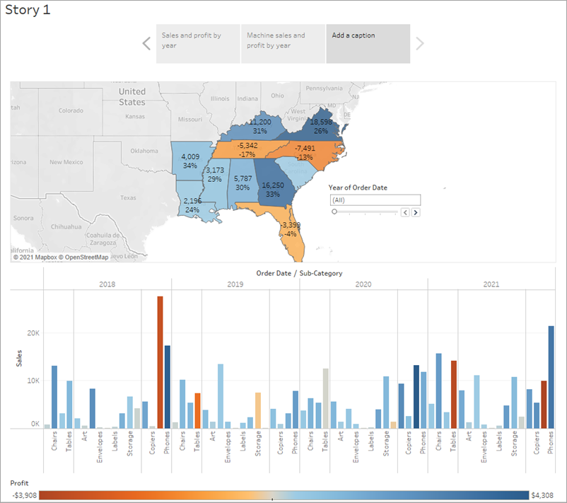

1. Add a caption like, "Underperforming items in the South."

To narrow your results to just North Carolina, start with a duplicate story point.

1. Select **Duplicate** to create another story point with your Regional Profit dashboard.
2. Select **North Carolina** on the map and notice that the bar chart automatically updates.
3. Select **All**on the Year of Order Date filter card.
4. Add a caption, for example, "Profit in North Carolina, 2018-2021."

Now you can walk viewers through profit changes by year in North Carolina. To do this, you will create four story points:

1. Select **Duplicate** to begin with your Regional Profit dashboard focused on North Carolina.
2. On the Year of Order Date filter, click the right arrow button so that **2018** appears.
3. Add a caption, for example, "Profit in North Carolina, 2018," and then click **Duplicate**.
4. Repeat steps 2 and 3 for years 2019, 2020, and 2021.

Now viewers will have an idea of which products were introduced to the North Carolina market when, and how poorly they performed.

Check your work! Watch "Make your point" in action.

*Click the image to replay it*



Finishing touches

On this story point that focuses on data from 2021, you want to describe your findings. Let's add more detail than just a caption.

1. In the left pane, select **Drag to add text** and drag it onto your view.
2. Enter a description for your dashboard that emphasizes the poor performance of machines in North Carolina, for example, "Introducing machines to the North Carolina market in 2021 resulted in losing a significant amount of money."

For dramatic effect, you can hover over Machines on the Sales in the South bar chart while presenting to show a useful tooltip: the loss of nearly $4,000.

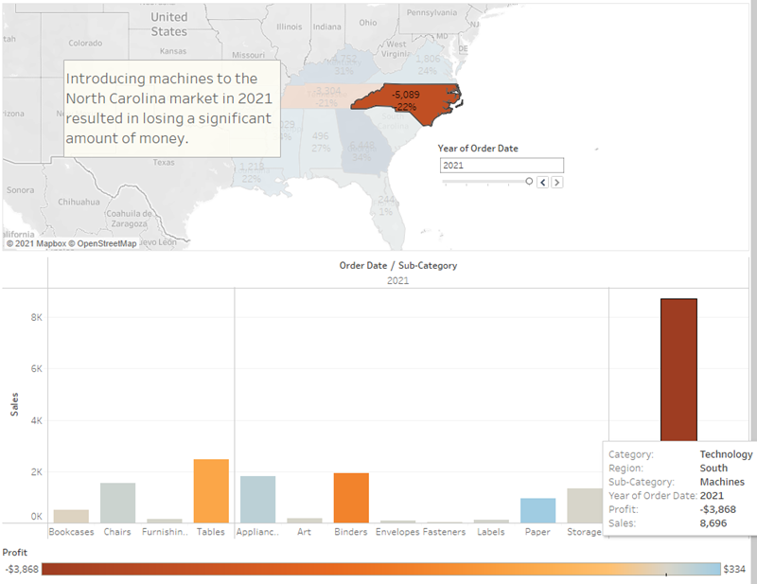

And now, for the final slide, you drill down into the details.

1. In the **Story** pane, click **Blank**.
2. From the **Story** pane, drag **Negative Profit Bar Chart** to the view.
3. In the **Year of Order Date** filter card, narrow the view down to **2021** only.

You can now easily see that the loss of machine profits was solely from Burlington, North Carolina.

1. In the view, right-click the **Burlington** mark (the bar) and select **Annotate** > **Mark**.
2. In the Edit Annotation dialog box that appears, delete the filler text and type: "Machines in Burlington lost nearly $4,000 in 2021."
3. Click **OK**.
4. In the view, click the annotation and drag it to adjust where it appears.
5. Give this story point the caption: "Where are we losing machine profits in North Carolina?"
6. Double-click the **Story 1**tab and rename your story to "Improve Profits in the South".
7. Review your story by selecting **Window** > **Presentation mode**.

Learn more: Size to fit.

Check your work! Watch "Finishing touches" in action.

*Click the image to replay it*



After you present

Your presentation went very well. The team is convinced that there is work to be done to increase profit in Burlington, North Carolina. And, they're curious to know why machines did so poorly in the first place. Your boss is thrilled—not only have you identified a way to address negative profit, you've got the team asking questions about their data.

To keep the lessons fresh in their minds, your boss asks you to email your team a document with your findings. It's a good thing that you know about sharing your visualizations with Tableau Server and Tableau Public.

Step 8: Share your findings

You've done a bunch of work—great work—to learn that Burlington, North Carolina needs some fine tuning. Let's share this information with your teammates.

**Before you continue**, select an option below:

* If you or your company does not use Tableau Server, or if you want to learn about a free, alternative sharing option, jump to Use Tableau Public.
* If you or your company uses Tableau Server, and you are familiar with what permissions are assigned to you, jump to Use Tableau Server.

Use Tableau Public

Your story was a hit. You're going to publish it to Tableau Public so that your team can view it online.

**Note:** When you publish to Tableau Public, as the name suggests, these views are publicly accessible. This means that you share your views as well as your underlying data with anyone with access to the internet. When sharing confidential information, consider Tableau Server(Link opens in a new window) or Tableau Online(Link opens in a new window).

1. Select **Server** > **Tableau Public** > **Save to Tableau Public**.
2. Enter your Tableau Public credentials in the dialog box.

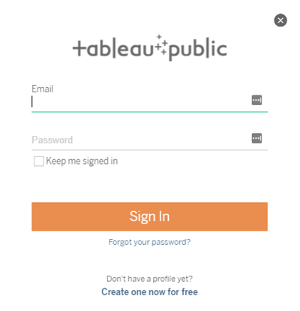

If you don't have a Tableau Public profile, click **Create one now for free** and follow the prompts.

1. If you see this dialog box, open the Data Source page. Then in the top-right corner, change the **Connection** type from **Live** to **Extract**.

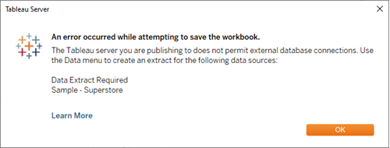

Learn more: Why did you have to create an extract? And what's an extract, anyway?

1. For the second (and last) time, select **Server** > **Tableau Public** > **Save to Tableau Public**.
2. When your browser opens, review your embedded story. It will look like this:

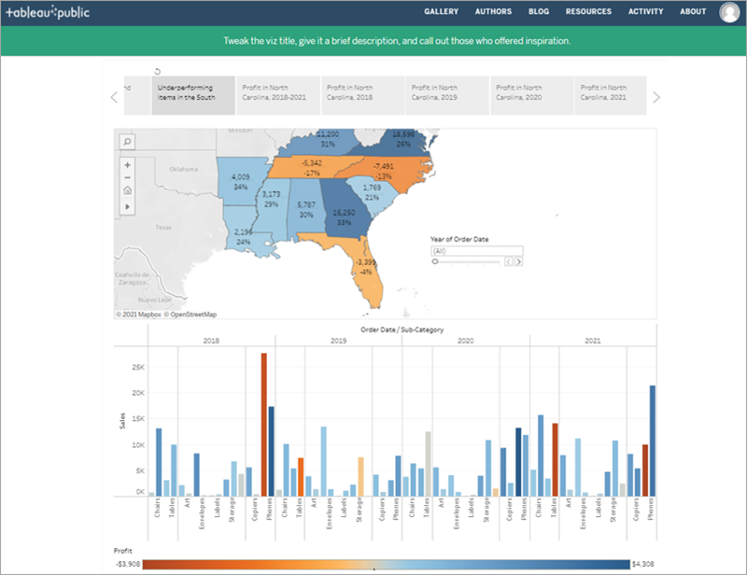

1. Click **Edit Details** to update the title of your viz, add a description, and more.
2. Click **Save**.

Your story is now live on the web.

1. To share with colleagues, click **Share** at the bottom of your viz.  
   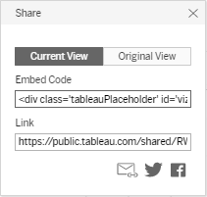
2. How do you want to share your story?
   1. Embed on your website: Copy the **Embed Code** and paste it in your web page HTML.
   2. Send a link: Copy the **Link** and send the link to your colleagues.
   3. Send an email using your default email client by clicking the email icon.
   4. Share on Twitter or Facebook by clicking the appropriate icon.

After you've completed these steps, click here to jump to the final section of the tutorial.

Use Tableau Server

Your story was a hit. You're going to publish it to Tableau Server so that your team can view it online.

Publish to Tableau Server

1. Select **Server** > **Publish Workbook** or click **Share** on the toolbar.
2. Enter the name of the server (or IP address) that you want to connect to in the dialog box and click **Connect**.

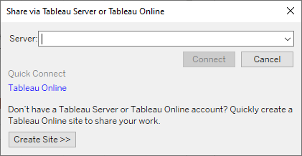

1. In the Name field, enter **Improve Profits in the South**.
2. If you want, enter a description for reference, for example "Take a look at the story I built in Tableau Desktop!"
3. Under **Sheets**, click **Edit**, and then clear all sheets except **Improve Profits in the South**.

Learn more: Share more than just your story.

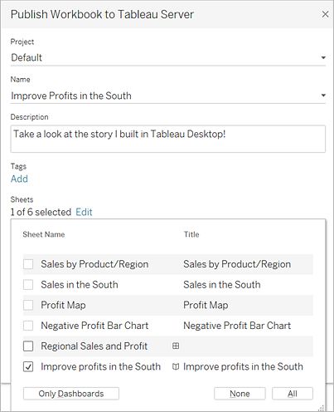

1. Click **Publish**.

Tableau Server opens in your internet browser. If prompted, enter your server credentials.

The Publishing Complete dialog box lets you know that your story is ready to view.

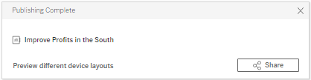

Great work! You've successfully published your story using Tableau Server.

Send a link to your work

Let's share your work with your teammates so that they can interact with your story online.

1. In Tableau Server, navigate to the Improve Profits in the South story that you published. You will see a screen like this:

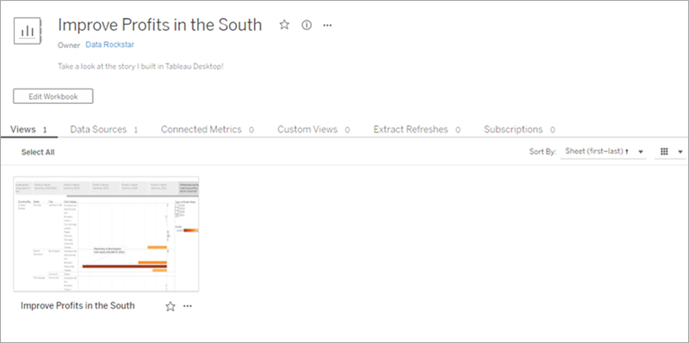

*If you had published additional sheets from your workbook, they would be listed alongside Improve Profits in the South.*

1. Click **Improve Profits in the South**.

Your screen will update to look like this:

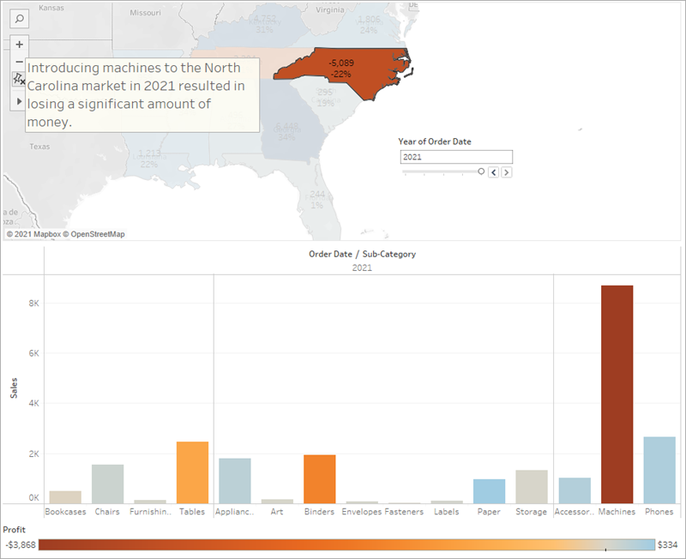

Awesome! This is your interactive, embedded story.

1. From the menu, select **Share**.

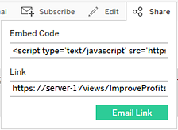

1. How do you want to share your story?
   1. Embed on your website by copying the **Embed Code** and pasting it in your web page HTML.
   2. Send a link by copying the **Link** and sending the link to your colleagues.
   3. Send an email by using your default email client: Click the email icon.

Congratulations, you did it!

You used Tableau Desktop to create a view of your product data, map the product sales and profitability by region, build a dashboard around your findings, tell a story to present, and share your findings on the web so that remote team members can take a look.

**You're a data rockstar.**

Well done! You successfully practiced the Tableau "Data Discovery" method:

* Ask a question
* Gather data
* Structure the data
* Explore the data
* Share insights

That's the basic workflow you'll follow when you work in Tableau, although you might find yourself doing a lot more revising in each stage than you did here. For example, it might take a few revisions to refine your initial question from something general (what's going on with sales?) to something specific (which city in the South is responsible for negative profit?).

And your revisions might take you in unexpected directions. That’s great, and that's what we hope will happen—we hope that you'll discover opportunities you didn't know existed when you first looked at your data.

If you're ready to jump in and start working with your data, then go forth and explore your data in Tableau! But if you want more information first, check out the Learning Library.